* Create a navbar that can both ***create a new to do list & browse to different lists***
  + Directly go to the Bootstrap ***Navbar documentations and the things we want are on the first example***

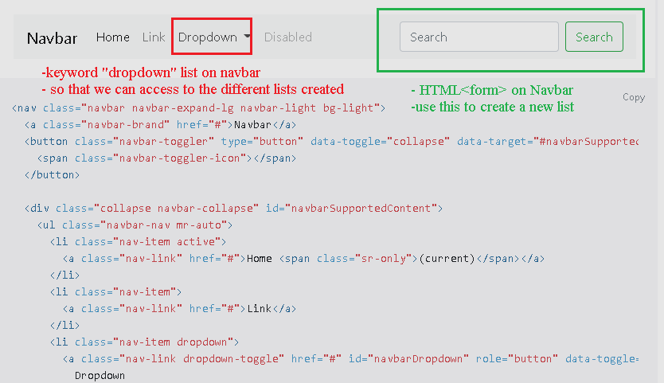

* + Trying to know more about Bootstrap via the example shown:
    - Boostrap ***‘active’ class***

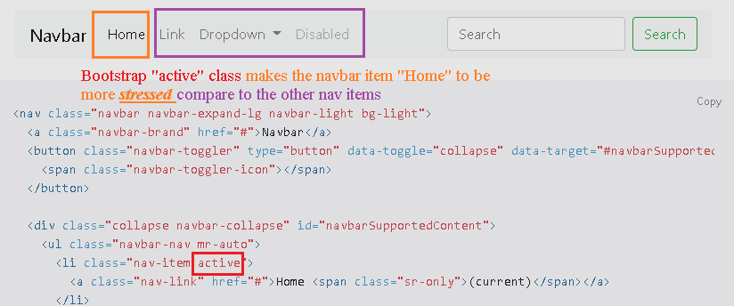

* + - Bootstrap ***“dropdown” & “dropdown-toggle” class***

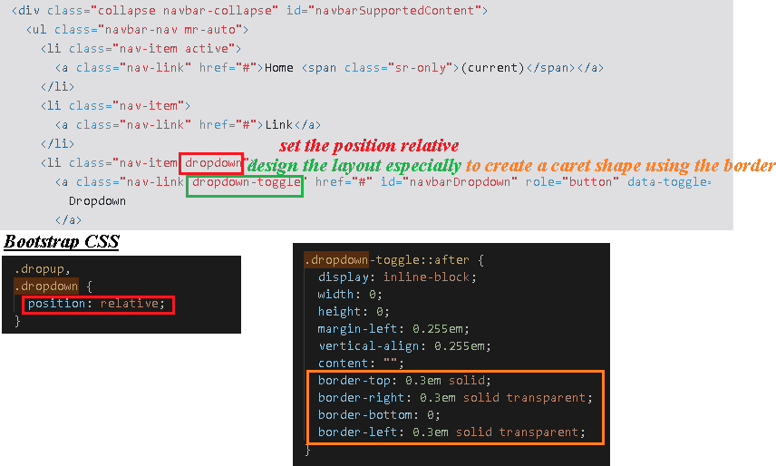

* + - Bootstrap ***mr & my class***

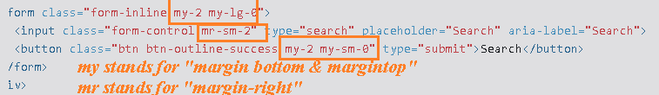

p/s: for further reference, can refer to ***Bootstrap spacing and below is a printscreen of the abbreviations***

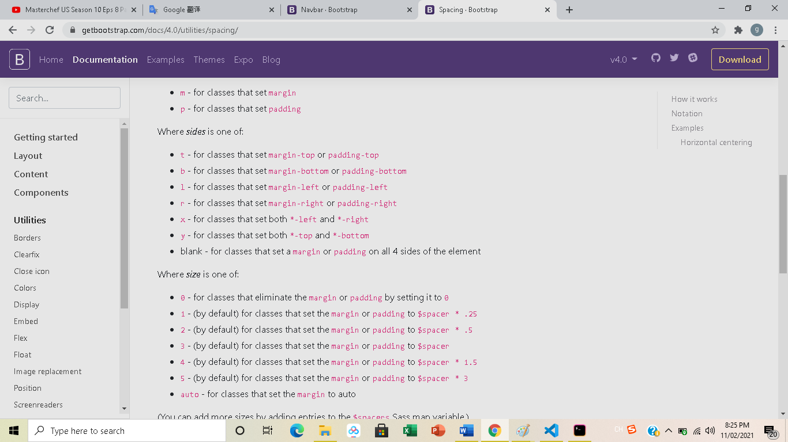

p/s: I stop here because other classes are used for styling and can be understood easily

* I was thinking of a way on how to ***throw back the error message to the front end***, so far the intuition is the ***NPM validator package, Mogoose error object***p/s: I gave up on the updating first as I think I should really speed up to deliver out my resumes (16 Feb 2021)

**Gains during Coding**

* When I was studying the Bootstrap CSS attempting to find out which of the Bootstrap class ***will be responsible for creating the caret shape for the drop-down list and I accidentally discover some interesting facts about the borders***

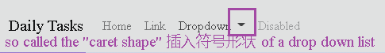

* + ***Bootstrap caret shape is made of borders, not content.*** The question is how can borders make such rectangular shape?
    - ***The best answer resource:*** [***https://stackoverflow.com/questions/7073484/how-do-css-triangles-work***](https://stackoverflow.com/questions/7073484/how-do-css-triangles-work)
    - Just a few things I need to add in for my future revision

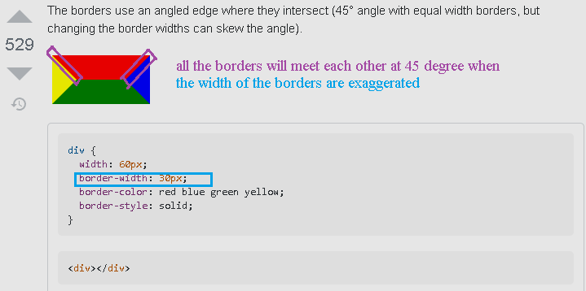~~p/s: I have demo with a lot of width-height pairs and it is true that even the width and the height of the contents deviate a lot, the~~ ***~~exaggerated width borders will still intersect with each other at 45degree. These borders will intersect at 45 degree and if the content has certain heights & widths, then an quadrilateral shapes will be formed in the middle~~***

p/s: This condition is only for the case ***when we try to exgerrate the border width to get some shapes, at normal situation just follow back what we have always learnt***

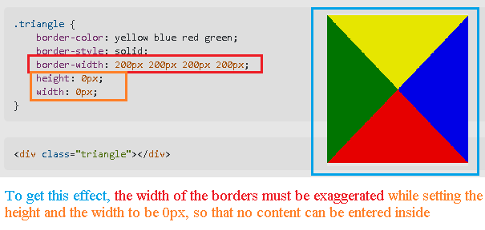

p/s: extra notes as of 11 Feb 2021, after pondering for a few days, I realized that it is ***not necessary that the border will intersect at 45 degree, instead what the real situation should be the left corner of the exaggerated border should join with the left corner of the content*** *(if exists)*

**Gains during Coding**

* We can ***specify which fields to return using Model.find() method by specifying the second parameter WITHIN A QUOTATION MARKS***

